Setting up Chem4Word V.Next VSTO Signing.

Browse to $/C4W V.Next/Main/Tools/Certificates/Developer

Double click on “Chem4WordAddIn.cer” click on “Install certificate” accepting the default settings

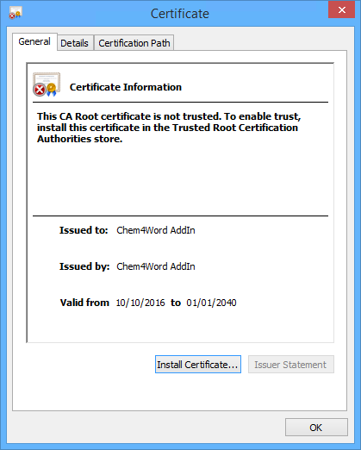

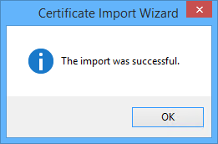

Open project Properties

Select “Signing” section

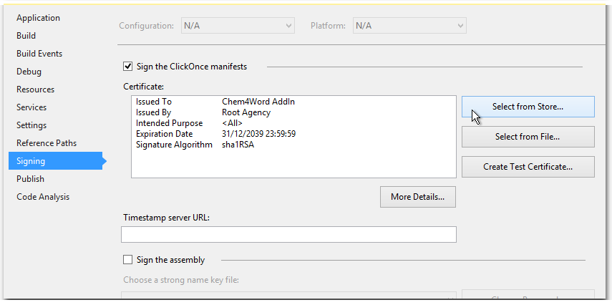

Click on “Select from Store…” Select the “Chem4Word AddIn” certificate, then click on OK

